UNIVERSITY OF WAH(UOW)

**DEPARTMENT OF COMPUTER** **SCIENCE**



**COURSE:** Physics Lab Task

**SUBMITTED TO:** Sir Abrar Hussain

**SUBMITTED BY:**  GROUP 4

**GROUPS MEMBERS:**

* **MUHAMMAD TALHA**
* **ABDULLAH SAJID**
* **HASSAN AMER**
* **MUHAMMAD HARIS**
* **HUZAIFA BUTT**
* **JUNAID KHATTAK**

**Title:**

**To measure the acceleration due to gravity by using simple pendulum**

**Apparatus:**

* A Clamp with Stand
* Bob with Hook
* Split Cork
* Stop Clock/Stop Watch
* Vernier Calipers
* Cotton Thread
* Half Meter Scale

**Diagram:**

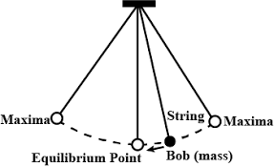

**Key Components of a Vernier Caliper:**

• **Suspension Point (Pivot)**: The fixed point where the pendulum is attached and can swing.

• **String or Rod**: A massless, inextensible string or rod that connects the pendulum bob to the suspension point.

• **Pendulum Bob**: The mass at the end of the string or rod that swings back and forth. It is typically a small heavy object.

• **Amplitude**: The maximum displacement of the pendulum from its equilibrium position.

• **Equilibrium Position**: The position where the pendulum is at rest, hanging vertically downward.

• **Length (L)**: The distance from the suspension point to the center of the pendulum bob.

**Theory of Simple pendulum:**

A simple pendulum consists of a heavy metallic (brass) sphere with a hook (bob) suspended from a rigid stand, with clamp by a weightless inextensible and perfectly flexible thread through a slit cork, capable of oscillating in a single plane, without any friction, with a small amplitude (less than 150). There is no ideal simple pendulum. In practice, we make a simple pendulum by tying a metallic spherical bob to a fine cotton stitching thread.

               The spherical bob may be regarded by as a point mass at its center G. The distance between the point of suspension S and the center G of the spherical bob is to be regarded as the effective length of the pendulum. The effective length of a simple pendulum, *L = l + h + r.*Where *l* is the length of the thread, *h* is length of hook, *r* is radius of bob.

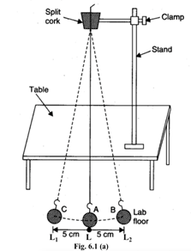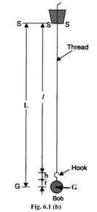

The simple pendulum produces Simple Harmonic Motion (SHM) as the acceleration of the pendulum bob is directly proportional to its displacement from the mean position and is always directed towards it. The time period (T) of a simple pendulum for oscillations of small amplitude, is given by the relation,

T = 2 π √ (L/g)

Where, g = value of acceleration due to gravity and L is the effective length of the pendulum.

 T2 = (4π2/g) X L             or           T2 = KL (K= constant)

               and, g = 4π2(L/T2)

If T is plotted along the Y-axis and L along the X-axis, we should get a parabola. If T2 is plotted along the Y- axis and L along the X-axis, we should get a straight line passing through the origin.

**Analysis:**

**Phase 1:**

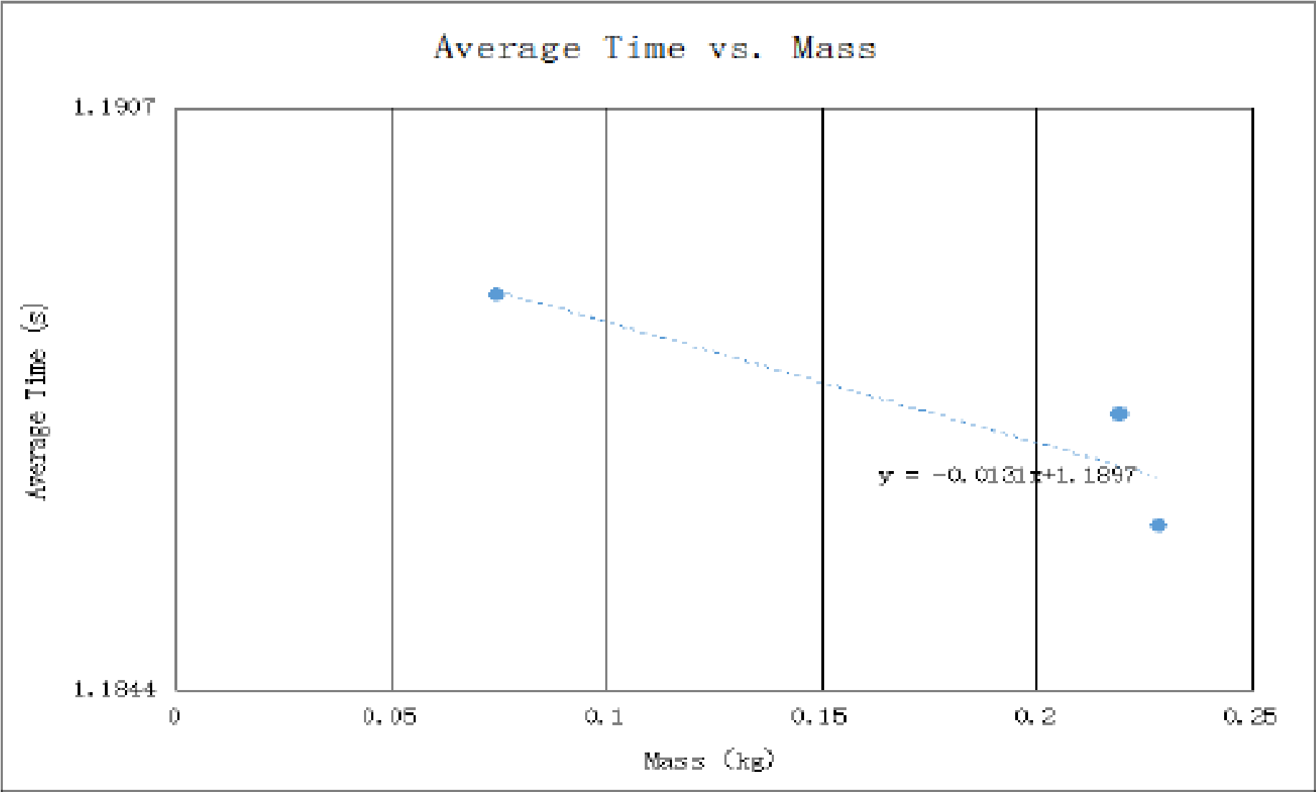

**Phase 2:**

Discussion:

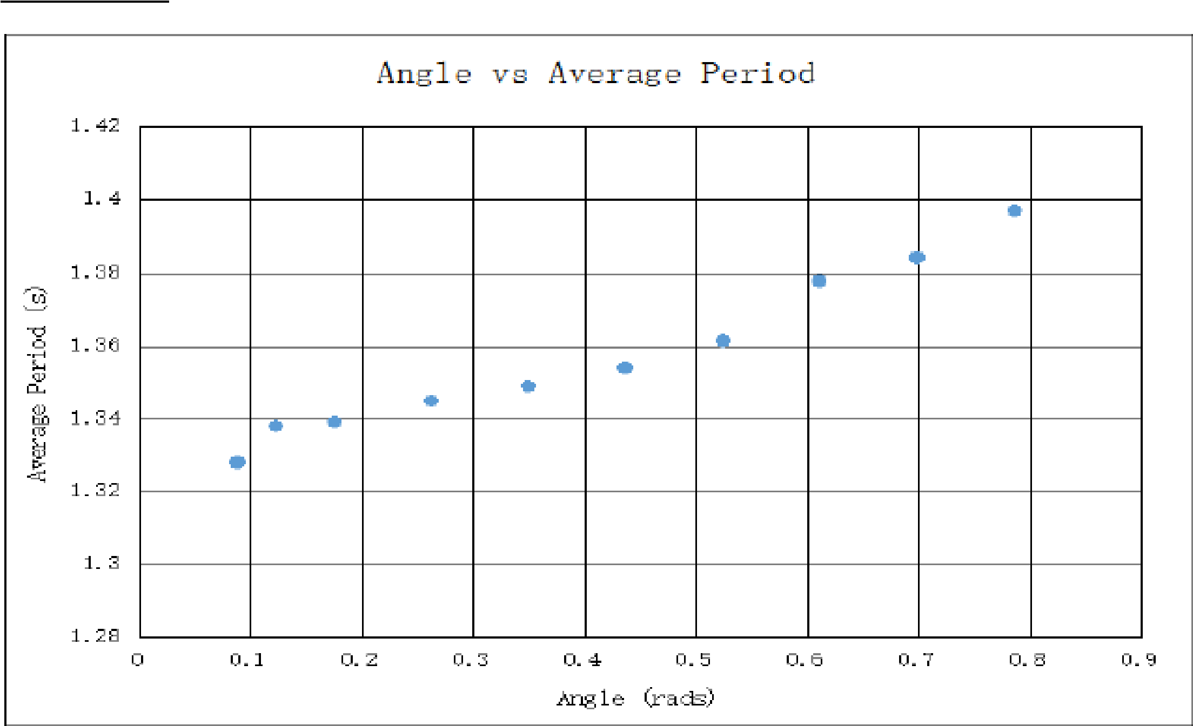

**Procedure:**

1. Find the vernier constant and zero error of the vernier callipers same as experiment 1.
2. Measure the radius (r) of the bob using a vernier callipers same as experiment 1.
3. Measure the length of hook (h) and note it on the table 6.1.
4. Since h and r is already known, adjust the length of the thread *l*to make *L = l + h + r*an integer (say L = 80cm) and mark it as M1 with ink. Making L an integer will make the drawing easier. (You can measure the distance between the point of suspension (ink mark) and the point of contact between the hook and the bob directly. Hence you get *l + h* directly).
5. Similarly mark M2, M3, M4 , M5, and  M6 on the thread as distance (L) of 90 cm, 100 cm, 110cm, 120cm and 130 cm respectively.
6. Pass the thread through the two half-pieces of a split cork coming out just from the ink mark (M1).
7. Tight the split cork between the clamp such that the line of separation of the two pieces of the split cork is at right angles to the line along which the pendulum oscillates.
8. Fix the clamp in the stand and place it on the table such that the bob is hanging at-least 2 cm above the base of the stand.
9. Mark a point A  on the table (use a chalk) just below the position of bob at rest and draw a straight line BC of 10 cm having a point A at its centre. Over this line bob will oscillate.
10. Find the least count and the zero error of the stop clock/watch. Bring its hands at zero position
11. Move the bob by hand to over position B on the right of A and leave. See that the bob returns over line BC. Make sure that bob is not spinning.
12. Now counting oscillations, from the instant bob passes through its mean position L, where its velocity is maximum. So starting from L it traverses LL2, L2L, LL1, L1L hence, one oscillation is completed. We have to find time for 20 such oscillations.
13. Now start the stop watch at the instant the bob passes through the mean position A. Go on counting the number of oscillations it completes. As soon as it completes 20 oscillations, stop the watch. Note the time t for 20 oscillations in the table 6.1.
14. Repeat the measurement at least 3 times for the same length.
15. Now increase the length of the thread by 10 cm or 15 cm (M2) and measure the time t for this length as explained from step 6 to 14.
16. Repeat step 15 for at least 4 more different lengths.

**Observations:**

***Vernier constant***

Vernier constant of the vernier callipers, V.C. = ______________ cm

Zero error, ±e = _____________cm

***Diameter of the bob and length of hook***

Observe diameter of the bob:= (i) ______cm, (ii)________cm, (iii)___________cm

Mean diameter of bob, d0 = _________cm

Mean corrected diameter of bob, d = d0 ±e = __________cm

Radius of the bob, r = d/2= ____________ cm

Length of the hook, h= __________cm

Standard value acceleration due to gravity, g1 : 980 cm s-2

Least count of stop clock = ____________s

Zero error of stop clock = ___________s

**Table 6.1 Determination of time-periods for different lengths of the pendulum.**

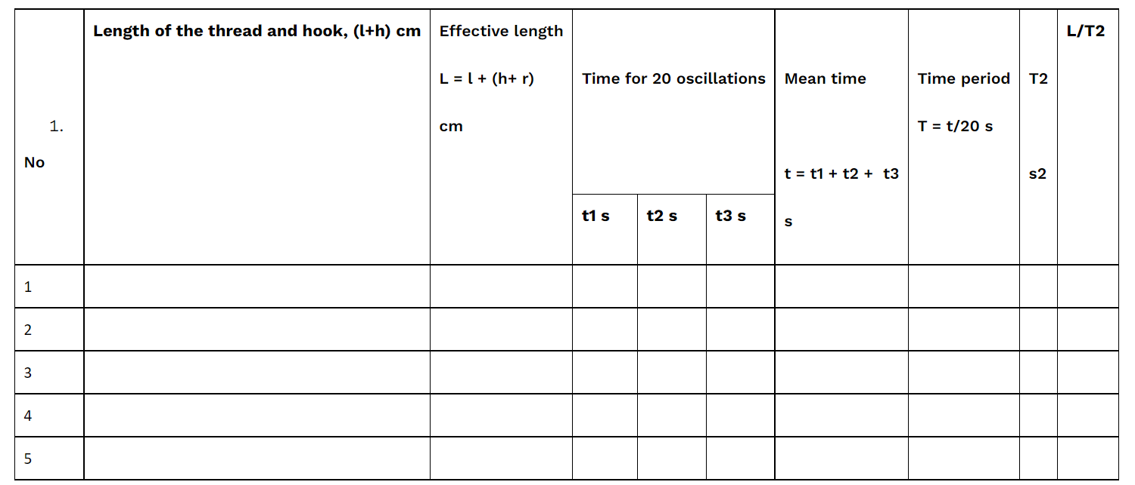

**Mean  = L/T2 = _______________________**

**Calculation:**

We know**,**T = 2 π √ (L/g)

 Experimental value, g1 = 4π2(L/T2) = ______________________

**So, %error = (g-g1)/g *100 = ______________________**

**Graph:**

***L vs T graph***

Plot the graph between L and T from the observations recorded in the table 6.1. Take L along X-axis and T along Y-axis. The L-T curve is a parabola. As shown in the figure 6.2. The origin need not be (0,0) point.

***L vs T2 Graph***

Plot the graph between L and T2 from the observations recorded in the table 6.1. Take L along X-axis and T2 along Y-axis. The L-T curve is a straight line passing through the (0, 0) point. So the origin of the graph should be chosen (0, 0). As shown in the figure 6.3.

***Determination of length of a seconds pendulum from graph:***

A second pendulum has time-period 2 s. To find the corresponding length of the pendulum from the L-T graph, draw a line parallel to the L-axis from the point Q1 (0, 2). The line interval the curve L-T at P1. So, the coordinates of P1 is (102, 2).

**Length of the seconds pendulum is _____________(102) cm.**

To find the length from the L-T2 curve, we, similarly, draw a line parallel to L-axis is form a point Q2 (0, 4). The line intersects the curve at P2. P2 has coordinates (100, 4).

**Length of the seconds pendulum is _______________(100) cm.**

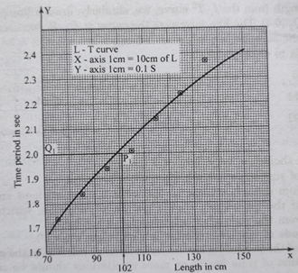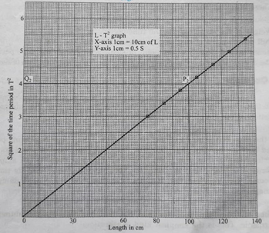

**Precautions :**

1. The thread should be very light and strong.
2. The point of suspension should be reasonably rigid.
3. The pendulum should oscillate in the vertical plane without any spin motion.
4. The floor of the laboratory should not have vibration, which may cause a deviation from the regular oscillation of the pendulum.
5. The amplitude of vibration should be small (less than 15) .
6. The length of the pendulum should be as large as possible in the given situation.’
7. Determination of time for 20 or more oscillations should be carefully taken and repeated for at least three times.
8. There must not be strong wind blowing during the experiment.

**Summary / Results:**

A simple pendulum is a mass attached to a string or rod that swings back and forth under the influence of gravity, exhibiting periodic motion. It demonstrates key principles of physics, such as simple harmonic motion, restoring forces, and energy conservation. The motion of the pendulum is dependent on its length and the gravitational constant, making it useful in experiments to measure gravitational acceleration. While the idealized model of a simple pendulum assumes small displacements and neglects factors like air resistance or friction, it still provides valuable insights and serves in various applications such as timekeeping, seismometers, and sensors. The results from studying a simple pendulum confirm its predictable, periodic behavior and its role in illustrating fundamental concepts of oscillation, energy, and motion in both educational and practical contexts.

**Applications**

1. **Timekeeping (Clocks)**: The simple pendulum was historically used in mechanical clocks to regulate the passage of time due to its periodic motion. The consistent oscillation allows for accurate time measurement.
2. **Seismometers**: In seismology, a modified pendulum (seismometer) is used to detect ground motion caused by earthquakes. The pendulum moves in response to vibrations, helping to measure the intensity and duration of seismic waves.
3. **Gravitational Experiments**: A simple pendulum is used in laboratory experiments to measure gravitational acceleration (g), as the period of oscillation depends on the length of the pendulum and the gravitational force.
4. **Pendulum-Based Sensors**: Pendulum motion is employed in sensors for detecting tilt or changes in orientation, such as in level measurement devices or vehicle suspension systems.
5. **Physical Demonstrations**: The simple pendulum is commonly used in classrooms and physics demonstrations to explain concepts of oscillation, energy conservation, and simple harmonic motion.
6. **Spacecraft Attitude Control**: Pendulum-based systems are sometimes used in spacecraft for stabilizing and controlling orientation, relying on the predictable motion of the pendulum to help orient the spacecraft.
7. **Mechanical Systems**: Pendulum-like mechanisms are used in some mechanical systems, such as automatic doors, or in the design of certain types of governors for regulating engine speeds.

**Advantages:**

1. **Simple Harmonic Motion**: For small displacements, the motion of a simple pendulum follows a predictable, periodic pattern, making it a classic example of simple harmonic motion.
2. **Easy to Analyze**: The motion of a simple pendulum can be easily described mathematically, with straightforward formulas for period, frequency, and amplitude, providing insights into oscillatory systems.
3. **Demonstrates Fundamental Principles**: It effectively demonstrates important principles in physics, such as energy conservation, restoring forces, and periodic motion.
4. **Uses in Timekeeping**: Due to its regular, consistent motion, the simple pendulum was historically used in mechanical clocks, offering a reliable way to measure time.
5. **Educational Tool**: It is commonly used in educational settings to teach students about oscillatory motion, forces, and the concepts of period, frequency, and amplitude.
6. **Scalability**: The principles of a simple pendulum can be applied to other systems with oscillatory behavior, making it a versatile model in understanding various physical phenomena.
7. **No Need for Complex Equipment**: A simple pendulum can be constructed easily and with minimal resources, making it cost-effective and accessible for experiments and demonstrations.

**Limitation:**

1. **Small Angle Approximation**: The simple pendulum assumes small oscillations (typically less than 15 degrees), where the restoring force is directly proportional to displacement. For larger angles, the motion deviates from simple harmonic motion.
2. **Air Resistance**: In real-world conditions, air resistance acts on the pendulum, causing energy loss and damping, which reduces the amplitude of oscillation over time.
3. **Non-Ideal String or Rod**: A real string or rod may have mass, elasticity, or stretch, which affects the motion, unlike the idealized assumption of a massless, inextensible string.
4. **Friction at the Pivot**: Friction at the suspension point can introduce energy loss, leading to slower oscillations and eventually stopping the motion.
5. **Gravitational Variations**: The period of a pendulum depends on the acceleration due to gravity, which can vary with altitude and location, thus affecting the accuracy of measurements.
6. **Assumption of No External Forces**: The model ignores external factors like wind, vibrations, or other forces that might affect the pendulum's motion.
7. **Idealized Point Mass**: The pendulum assumes the bob to be a point mass, neglecting its shape and size, which can influence its motion in real situations.